ROTARY CLUB OF SUGAR HOUSE

P.O. Box 526102

Salt Lake City UT 84152-6102

www.rotaryclubofsugarhouse.org

NEWS RELEASE
FOR IMMEDIATE RELEASE
CONTACT: Susan J. Marks, 801.694.3489
susanjmarks@yahoo.com

Rotary International President to Visit Salt Lake City for Sugar House Rotary’s 75th Anniversary

(May 4, 2011) — The president of Rotary International, one of the world's largest service organizations, will join the Rotary Club of Sugar House on May 6 for its 75th anniversary gala at Little America. As part of the celebration, he will recognize the Club’s Past-presidents and its 75 years of extraordinary local and global service, and will present two Rotary service awards to local leaders.

Ray Klinginsmith, an attorney from Kirksville, Missouri, took office as president of Rotary International on 1 July 2010.

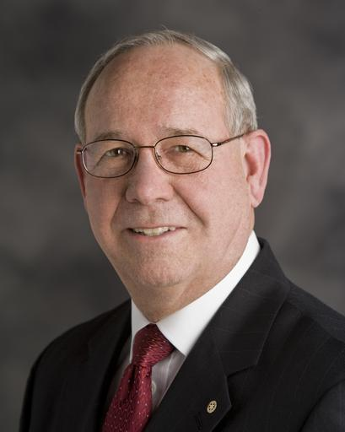
As president, Klinginsmith leads a global network of 1.2 million business and professional leaders who, through volunteer service, help meet the needs of communities worldwide. President Klinginsmith will focus his visit on the celebration with the second oldest Rotary Club in Utah.

The Rotary Club of Sugar House, The Sweetest Club in all of Rotary, has a long-standing tradition of leadership in Rotary International as well as countless hours volunteered and dollars raised for local and international service and humanitarian projects.

The Utah Chili Open, the largest Rotary fundraising event in Utah, has raised $3.74 million in 20 years in partnership with and support of smaller local charities.

The Sugar House Club is the lead club on a Rotary Global Grant, in partnership with 8 local Utah clubs and 10 clubs from the western region of Columbia. The grant is providing clean water and sanitation facilities to 30 schools and communities in Colombia. The Church of Jesus Christ of Latter Day Saints is a partner and is providing matching funds.

The Rotary Club of Sugar House has supported and continues to support numerous local projects and organizations including the Rotary Dictionary project (distribution of dictionaries to third graders in Utah), Hidden Hollow in Sugar House, Primary Children’s Medical Center, and the Utah Food Bank among others.

Klinginsmith will present the Ethics in Education Award to Dr. Michael S. Bassis, President of Westminster College, for achievement of high ethical standards as a core value in education.

The Vocation Excellence Award for Humanitarian Service will be presented to Dr. Alan S. Crandall, M.D., Senior Vice-chairman and Professor of Ophthalmology at the University of Utah’s John A. Moran Eye Center.

During his one-year term as president, Klinginsmith is encouraging Rotary’s 33,000 clubs to partner with local governments and nongovernmental organizations to initiate projects that improve literacy rates and provide sustainable sources of food and clean water to communities in developing countries.
He also oversees Rotary’s top priority of eradicating polio, a crippling and potentially fatal disease that still threatens children in Africa and Asia. Since 1985, Rotary club members have contributed more than $800 million and countless volunteer hours to the effort and are now working aggressively to raise an additional $200 million to match a $355 million challenge grant from the Bill & Melinda Gates Foundation. Great progress has been made, and the incidence of polio infection has plunged from about 350,000 cases in 1988 to fewer than 2,000 in 2008. To learn more about polio eradication, visit rotary.org/endpolio.

The Rotary Club of Sugar House has raised over $10,000 in the last year and has exceeded its Gates Foundation challenge grant commitment.

Rotary also sponsors the largest privately funded international scholarship program in the world. Since 1947, Rotary has contributed roughly $500 million to fund 38,000 students from 100 countries. These cultural ambassadors use the skills they acquire through their studies abroad to help their communities.

Klinginsmith was one of these cultural ambassadors in 1961, when he studied at the University of Cape Town as a Rotary Foundation ambassadorial scholar. “This program is an excellent opportunity for young people to expand their worldview and help promote goodwill,” said Klinginsmith. “As a former scholar in this program, it will be rewarding for me to lead the very organization that provided me with such a valuable, life changing experience.”

A member of Rotary for more than 40 years, Klinginsmith is a member of the Kirksville Rotary club.

# # #

Founded in Chicago in 1905, Rotary is a worldwide organization of business and professional leaders who provide humanitarian service and help to build goodwill and peace in the world. Rotary’s global membership is approximately 1.2 million men and women who belong to more than 33,000 Rotary clubs in more than 200 countries and geographical areas.

