FOR IMMEDIATE RELEASE:
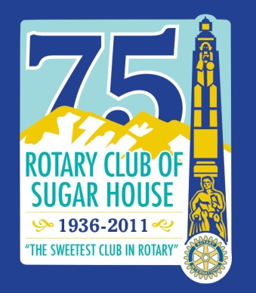

Governor Declares May 6, 2011 “Rotary Club of Sugar House Day”
To Celebrate Its 75 Years of Service

Salt Lake City, Utah - April 28, 2011- Today Governor Gary Herbert signed a Resolution declaring May 6, 2011 “Rotary Club of Sugar House Day” in the State of Utah. The Rotary Club of Sugar House will celebrate 75 years of service to the community with an Anniversary Gala at the Little America Hotel, Friday evening, May 6. A reception honoring Past Presidents will be held from 5:30 P.M. – 7:00 P.M. Dinner and a program will follow.
“Celebrating this milestone is celebrating 75 years of Sugar House Rotary’s commitment to our community,” says President Therese Milad. “We’re looking back and celebrating all that we’ve accomplished as a club. It’s a legacy of service that we hope to continue for another 75 years.”
Dignitaries and local leaders attending the 75th Anniversary Gala include Rotary International President Ray Klinginsmith, Congressman Jim Matheson, Salt Lake County Mayor Peter Corroon, Salt Lake City Mayor Ralph Becker, State Senator Gene Davis, Rotary District Governor Penny Atkinson, District Governor Elect Charles Richard Cambra III and many former Rotary District Governors and Club Presidents. The Sugar House Club will present the Rotary Distinguished Award to Westminster College President Dr. Michael Bassis for Exceptional Ethics in Education and the Vocational Excellence through Humanitarian Service Award to Alan S. Crandall, M.D. of the Moran Eye Center and The Eye Institute of Utah. Iman Rick Nosseir will give the invocation and the Burmese Boy Scout Troop will present the United States Flag and Pledge of Allegiance.
The Rotary Club of Sugar House was established in 1936 by local business leaders Marvin O. Ashton, Charles L. Snelgrove and A.C. Smoot. Rotary is an organization of business and professional leaders united worldwide who provide humanitarian service, encourage high ethical standards in all vocations, and help build goodwill and peace in the world. There are more approximately 1.2 Rotarians who belong to more than 33,000 Rotary Clubs in more than 165 countries around the world. The Sugar House Rotary hosts the annual Chili Open which raised $193,000 this year.
Contact: Therese J. Milad
President, Rotary Club of Sugar House
(801) 599-9410
miladhome@gmail.com
###

